# Datatypes and Format Specifiers Assignment

1. WAP to read the following information at run time and to display. Choose appropriate data type and format specifier.

1. username [maximum of length 125]
2. age
3. Salary [float]
4. Designation code [as short type with values {1, 2, 3, 4, 5, 6}
5. Gender [a single char field]

**Ans:**

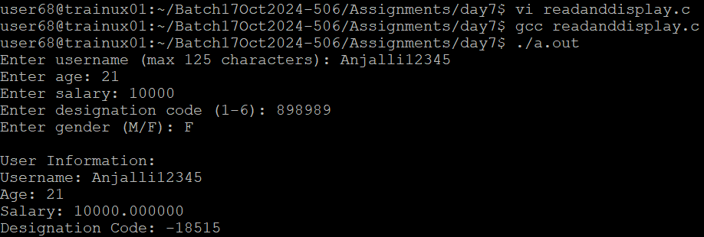

2. WAP to read a user choice as ‘y’ or ‘Y’ or ‘n’ or ‘N’ and display read choice as “Yes” or “No”

according to the input received.

‘y’ or ‘Y’🡪 display “Yes”

‘n’ or ‘N’🡪 display “No”

for any other character received 🡪 display “invalid character” and exit

**Ans:**

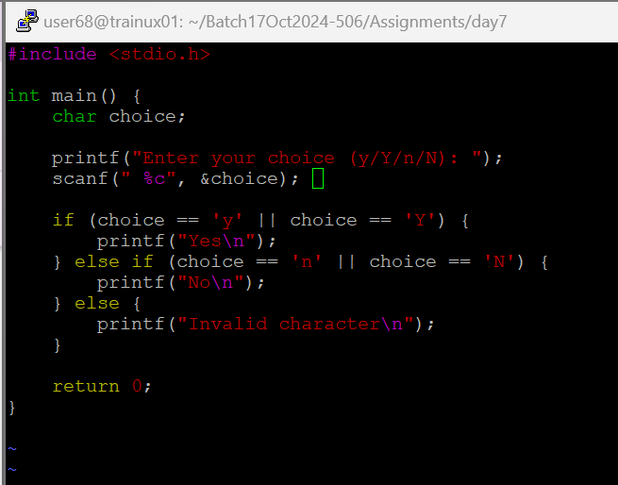

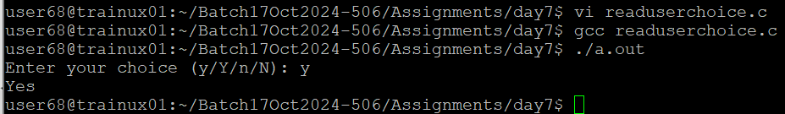

3. WAP to read a number in decimal (0-127) and display it in 2 digit hex characer.

**Ans:**



